
Company
Logotype

Cone Beam Computed Tomography- Report



Porur Dental X-rays & CBCT

Patient Name : Miss. Rini | Date of Report : 21.03.2024
Age/ Gender : 24 years/ Female | Region of Interest : CBCT Sectional Mandible
Referring doctor: Dr. Ishwariya. S | Indication : Implant assessment
Clinical Notes: Nil
PATIENT INFORMATION

CBCT- Sectional Mandible provided
CBCT – IMAGE DETAILS

RADIOGRAPHIC INTERPRETATION

- Complete loss of crown and root portion in relation to 48.
- In relation to 47, partial loss of crown structure involving enamel, dentin and approximating the pulp is evident.
- The alveolar bone in relation to the mandibular ridge is present with normal trabecular pattern.

IMPLANT ASSESSMENT

 | 47 region
Sub-Crestal (in mm) | 10.71
Mid- Crestal (in mm) | 13.2
Distance between alveolar ridge and the inferior alveolar nerve canal (in mm) | 11.76
Distance between alveolar ridge and the inferior border of mandible (in mm) | 22.86

RADIOGRAPHIC IMPRESSION

- Partially edentulous area: 48
- Fractured crown: 47

Kindly correlate with clinical findings


IMAGES FOR REFERENCE

RECONSTRUCTED PANORAMIC VIEW

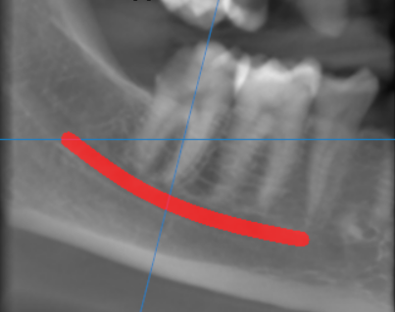

3-DIMENSIONAL VIEW

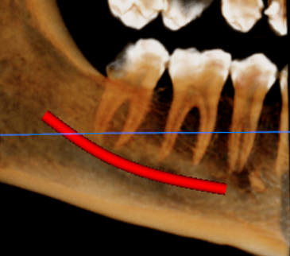

CROSS SECTIONAL VIEW

47 region | 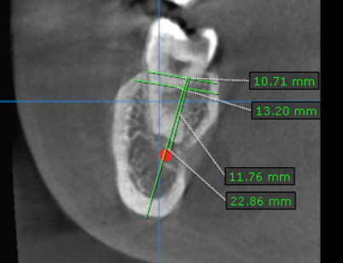

**** End of report ****

